ERD: Degree, Cardinality, Participation

Degree of Relationship ( درجة العلاقة )
كل العلاقات في هذا المشروع هي Binary) ثنائية( علاقة بين كيانين فقط
لأنه لا توجد علاقة تشمل 3 كيانات في نفس الوقت (Ternary).
User – Favorite ---→ Binary
User – Order ---→ Binary
User – Cart ---→ Binary
User – Medicine_Requests ---→ Binary
User - Medicine_Availability ---→ Binary
Medicine_Request - Medicine_Availability ---→ Binary
Notifications – User ---→ Binary
Notifications – Medicine_Request ---→ Binary
Cart – Cart_Items ---→ Binary
Cart – Order ---→ Binary

=========================================================

Cardinality Constraints ( عدد العناصر )

العلاقة Cardinality
------------ -----------------------
User – Favorite User (1) → Favorite (M)
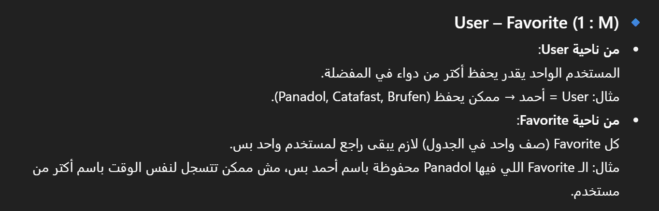

User – Order User (1) → Order (M)
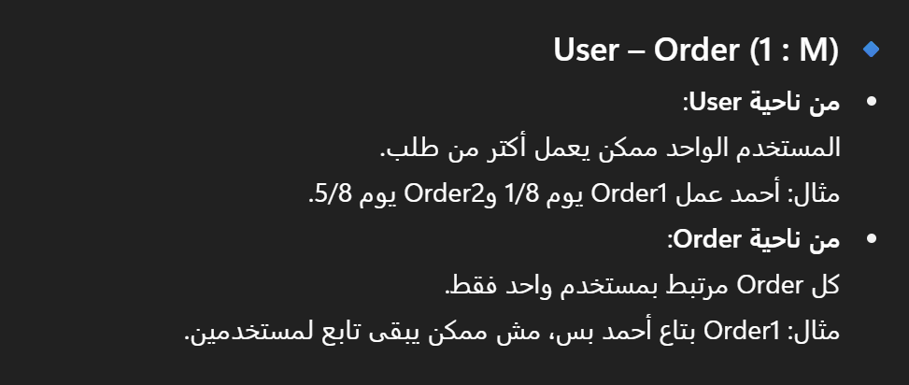

User – Cart User (1) → Cart (1)
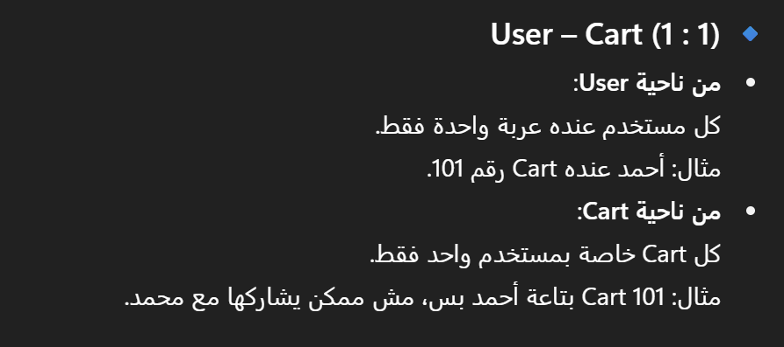

User – Medicine_Requests User (1) → Medicine_Requests (M)

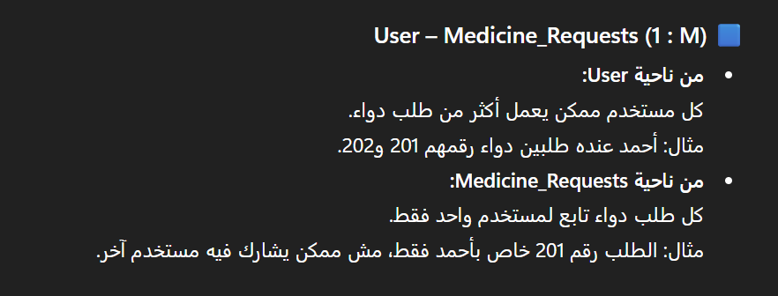

User - Medicine_Availability User (1) → Medicine_Availability (M)

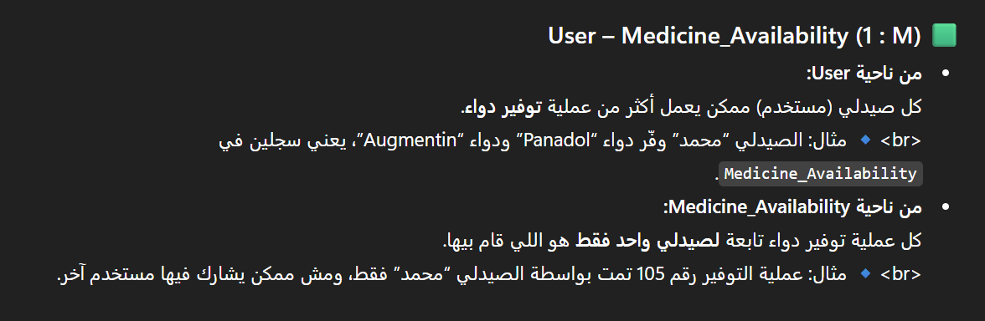

Medicine_Request - Medicine_Availability Medicine_Request (1) → Medicine_Availability (M)

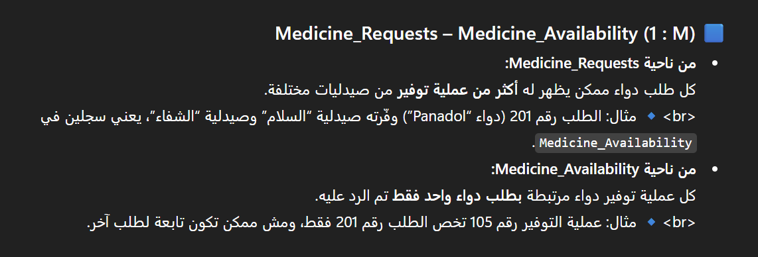

Notifications – User Notifications (M) → User (1)
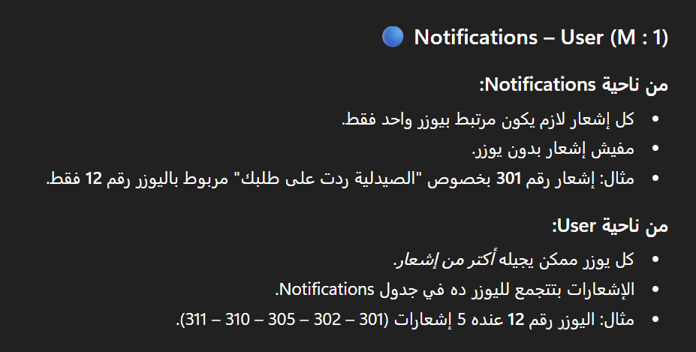

Notifications – Medicine_Request Notifications (M) → Medicine_Request (1)

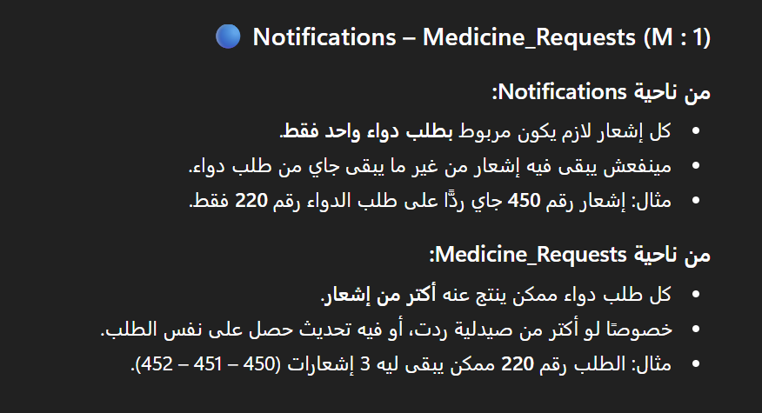

Cart – Cart_Items Cart (1) → Cart_Items (M)
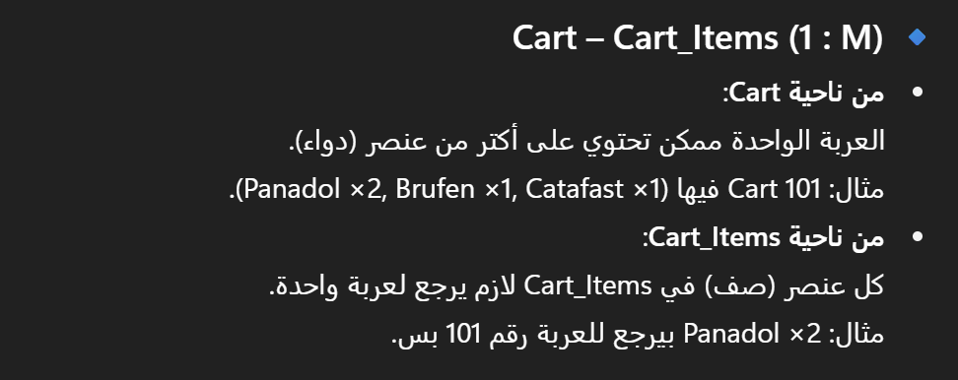

Cart – Order Cart (1) → Order (1)
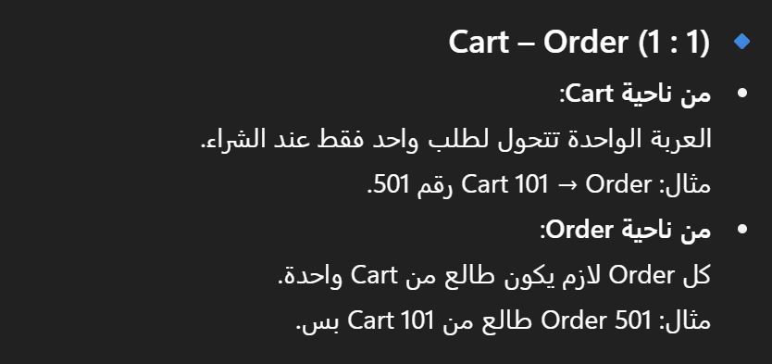

=========================================================

Participation Constraints ( قيد المشاركة )

Mandatory --- ( Total ) إلزامي
Optional --- ( Partial ) اختياري

العلاقة
------------
- User – Favorite
User إلزامي
Favorite اختياري
-----------------------------------------------------------------------
- User – Order
User إلزامي
Order اختياري
-----------------------------------------------------------------------
- User – Cart

User إلزامي
Cart إلزامي
-----------------------------------------------------------------------
- User – Medicine_Requests

User اختياري
Medicine_Requests إلزامي
-----------------------------------------------------------------------

- User – Medicine_Availability

User اختياري
Medicine_Availability إلزامي
-----------------------------------------------------------------------
- Medicine_Request – Medicine_Availability

Medicine_Request اختياري
Medicine_Availability إلزامي

-----------------------------------------------------------------------
- Notifications – User
Notifications إلزامي
User اختياري
-----------------------------------------------------------------------
- Notifications – Medicine_Request
Notifications إلزامي
Medicine_Request اختياري

-----------------------------------------------------------------------
- Cart – Cart_Items

Cart اختياري
Cart_Items اختياري
-----------------------------------------------------------------------
- Cart – Order

Cart إلزامي
Order إلزامي

=========================================================

